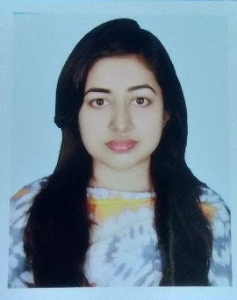**Resume of**

**Samia Rahamn**

1462-South Donia

Kodomtoli,Dhaka-1236

Mobile: 01319327430

E-mail: [tatamoto7777@gmail.com](mailto:tatamoto7777@gmail.com)

**Career Objective:**

Looking for hard and Challenging Job where I will have the scope to utilize my potentiality, adaptability and skill to do something innovate and from where I will be able to enhance my knowledge.

**Educational Qualification:**

**B.sc In (Computer Science and Engineering):**

Institute : Dhaka City College

Department : Department in Computer Science and Engineering

Session : 2014-2015

Result : (CGPA) 3.48 on scale of 4.00

Passing year : 2019

**Higher Secondary School Certificate (HSC):**

Institute : Motijheel Model School & College

Board : Dhaka

Group : Science.

Result : (GPA) 4.60 on scale of 5.00

Passing year : 2014

**Secondary School Certificate (SSC):**

Institute : A.K High School & College

Board : Dhaka

Group : Science

Result : (GPA) 5.00 on scale of 5.00

Passing year : 2012

**Computer Skills:**

* Microsoft Office, Microsoft excel, MS Power Point, MS Acces.
* HTML, CSS, PHP, MYSQL, JAVA Script.
* Word Press.
* PL/SQL, Bootstrap 4.
* C, C++,java
* Hardware maintenance.

**Language :**

* **Bangla:** Excellent in both writing and speaking**.**
* **English:** Excellent in writing and good in speaking.

**Personal Attributes:**

* Self-confident and being positive.
* Ability to manage time & being flexible.
* Ability to work efficiently under pressure & fulfill deadline.
* Self-motivated individual with strong drive to achieve target goal.

**Personal Information:**

Name : Samia Rahman

Father’s Name : Md. Habib

Mother’s Name : Mrs. Sahanaz Begum

Date of Birth : 2 September 1997

Nationality : Bangladeshi

Marital Status : Unmarried

Religion : Muslim

Gender : Female

Permanent address : 1462- South Donia,

Kodomtoli,Dhaka-1216

**References:**

1. **Md. Ashraf Uddin**

**Designation**: Register

**Organization**: BDU

**Mobile**:01711054745

**Relation**: Uncle .

1. **Md. Azharul Haque**

**Designation**: Deputy Librarian

**Organization**: Dhaka University

**Mobile**:01682556462

**Relation**: Uncle .

##### Sincerely yours:

………………………

(Samia Rahman)